- 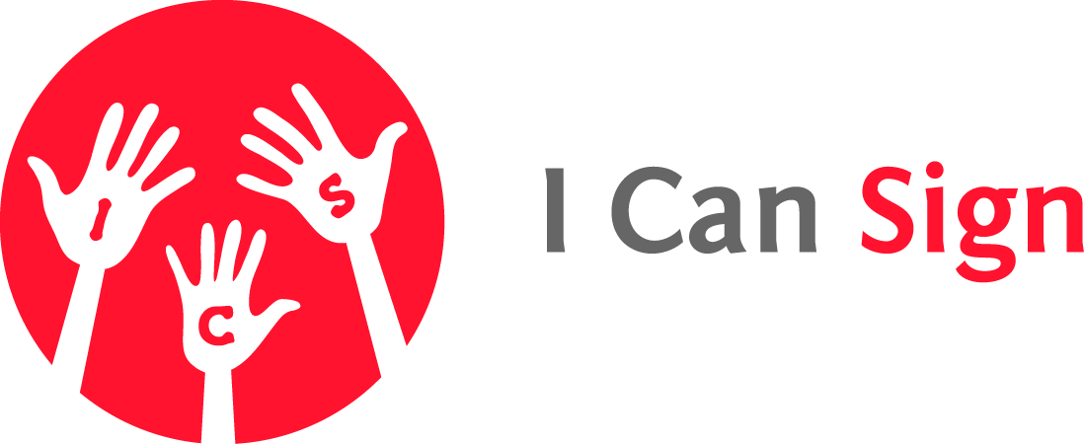

Enrolment Form & Learning Agreement

Section 1: Personal Details
First Name: | Surname:
Title (Mr, Mrs, Ms, Miss, etc.): | Male/Female:
Date of Birth:

Section 2: Contact Details

Address: | Mobile Phone:
Postcode: | Email:

Section 3: Course Details & Fees (Please indicate)
British Sign Language Level 2 Award:  Thursday 26/09/19: 18.00 - 21.00  [Must have achieved the BSL Level 1 award] | Venue:  Action on Hearing Loss  Poolemead Centre,  Watery Lane  Twerton  Bath BA2 1RN

Section 4: Payment (Please Indicate)
Level 2 Course Fee  One Payment in Full - £575  Payment will need to be made by the start date of course enrolled. | Instalment Plan: [Additional £25 admin fee]  1st Instalment - £250  2nd – 8th: £50  [Last payment will need to be made by the end of April]
CHEQUE: CASH: BACS: | CHEQUE: CASH: BACS:

Refunds and Cancellation Policy:
You have 14 days from payment by law to cancel and a refund will be given. After that date refunds are not given, once you sign the learning agreement you agree to pay for the course in full, if you do not continue the duration of the course you agree to still pay the full fee.

Section 5: Learning Agreement

I declare that, to the best of my knowledge, the information I have provided whilst enrolling is correct and I agree to all ICS policies.
- I intend to attend the course I have enrolled on and I am aware of the commitment required.
- I understand that should my sponsor fail to pay my fees, I will remain liable to pay. (If applicable)
- I understand that if I do not continue the course for any reason I am still liable to pay the full amount of the course.

Section 6: Privacy Policy
- A copy of our privacy policy can be found here.
- By submitting this enrolment form you are agreeing to allow us to use your personal information as stated in our Privacy Policy above.

Section 7: Information for your BSL Assessments required by Signature

Please Select for Signature Assessment Purposes only:

Ethnic Group: | State Here:
Bangladeshi | Black – African Heritage | Black – Carribean Heritage | Black – Other | Chinese | Indian
Pakistani | White - European | White – British | White – Other | Not Known | Prefer Not to Say

Social Group:

Deaf | Deafened | Hard of Hearing | Deaf-Blind | Hearing

EMERGENCY Contact Details:
Relevant Medical or
Access Issues:

Section 8: Terms & Conditions

- Once a student has enrolled on a course (that is when their application form and due payment have been received) The Centre are unable to refund the course fee, except when that course has been cancelled by The Centre.

- All fees are shown on both the Course Information Sheet and the Application Form.

- When arrangement have been agreed, in writing, for an individual student to pay the course fees by way of instalments, and that student drops out of their course before its conclusion, any outstanding monies owed by the student at that time will become immediately payable.

- When student commences their course they will be provide with a timetable detailing the times and dates of their course; this will include any date changes necessitated by public holidays.

- There will be no extra tuition time in the event of a student missing a class or arriving late.

- Neither The Centre will be liable for any loss of damage to student’s personal property.

- A student’s motor vehicle will be parked at his or her own risk.

- A student will be expected to comply with all of the regulation at The Centre regarding Health and Safety in respect of fire, smoking and other procedures.

- All mobile telephones must be switched off or on silent during a lesson.

- A student may appeal in respect of an examination failure: appeal procedures and examination re-take fees are available on request.

- If, at any time, a student wishes to discuss their progress or have any comments or suggestions, then they can speak freely with their teacher or contact The Centre.

Signed [Student]: | Date:

Typing your name in box above and emailing back to info@ics-centre.co.uk is acceptable.

Section 7: Returning your Forms & Payment

- You can re-attach them to an email and send them back to us via this email address: info@ics-centre.co.uk [recommended] an invoice will follow when we receive this form.

- You can post them to our main Bristol office with a cheque to the following address:

Please sign below and send to:  ICS CENTRE  C/O Mhairi Threlfall  3FC082 UWE Frenchay Campus  Cold Harbour Lane  Frenchay  Bristol  BS16 1QY  Or re-attach them to an email and send them back to us via this email address: info@ics-centre.co.uk [recommended] an invoice will follow when we receive this form. | Please address cheques to:  ICS CENTRE
Signed [Student]: | Date:

