- 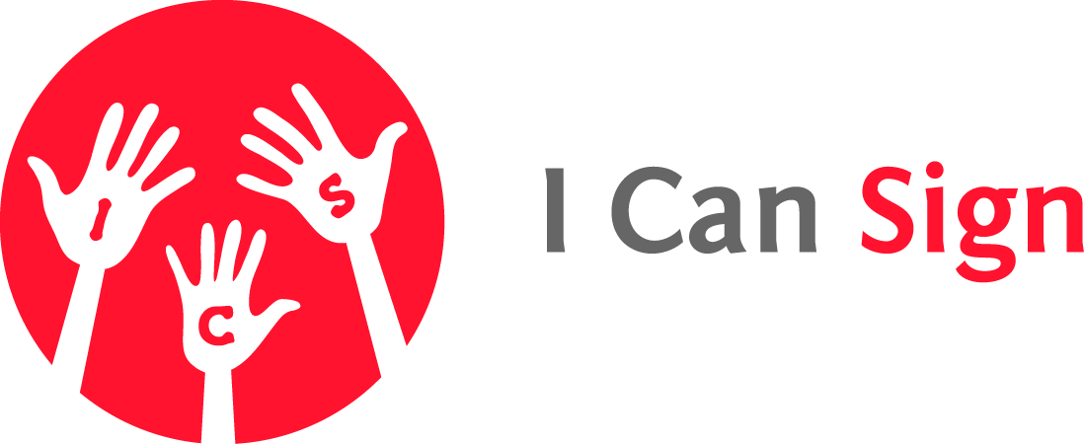

Enrolment Form & Learning Agreement

Section 1: Personal Details
First Name: | Surname:
Title (Mr, Mrs, Ms, Miss, etc.): | Male/Female:
Date of Birth:

Section 2: Contact Details

Address: | Mobile Phone:
Postcode: | Email:

Section 3: Course Details & Fees (Please indicate)
British Sign Language Level 2 Award:  Wednesday 23/09/15: 15.00 - 18.00  [Must have achieved the BSL Level 1 award] | Level 2: Fee £450 –
You may be entitled to claim a reduced (concessionary) fee if you are Under 16 years of age before the start date of the course.
Paying the concessionary fee is dependent on providing valid evidence of benefit at the time of enrolment and we are unable to process your enrolment at the concessionary fee without this.

Section 5: Payment (Please Indicate)
One Payment in Full  Payment will need to be made by the start date of course enrolled. | Instalment Plan: [Additional £25 admin fee]  1st Instalment - £225  [Payment will need to be made by the start date of course enrolled]
CHEQUE: CASH: BACS: | CHEQUE: CASH: BACS:

Refunds and Cancellation Policy:
You have 14 days from payment by law to cancel and a refund will be given. After that date refunds are not given, once you sign the learning agreement you agree to pay for the course in full, if you do not continue the duration of the course you agree to still pay the full fee.

Section 6: Learning Agreement

I declare that, to the best of my knowledge, the information I have provided whilst enrolling is correct and I agree to all ICS policies.
- I intend to attend the course I have enrolled on and I am aware of the commitment required.
- I understand that should my sponsor fail to pay my fees, I will remain liable to pay. (If applicable)
- I understand that if I do not continue the course for any reason I am still liable to pay the full amount of the course.

Section 7: Returning your Forms

- You can re-attach them to an email and send them back to us via this email address: cardiff@ics-centre.co.uk [recommended] an invoice will follow when we receive this form.

- You can post them to our main Bristol office with a cheque to the following address:

Please sign below and send to head office:  I Can Sign Centre  C/O Mhairi Threlfall  UWE 2FC100  Cold Harbour Lane  Frenchay  Bristol  BS16 1QY | Please address cheques to:  I Can Sign Centre
Signed [Student]: | Date:
Signed [ICS Centre]: | Date:

